Urgent Community Objection Needed Against Construction of Large 5 Storey Apartment Block at 76 Mitchell Road (DA D/2012/1627) – Submissions Close Tue 11th December (in 1 DAY*)
Mon 10th December, 2012
Dear Fellow Alexandria / Erskinville Residents,
We, residents in Buckland & Fountain Streets and the Alexandria Residents’ Action Group (ARAG) have only just become aware of the DA to demolish the Auction Centre at 76 Mitchell Road, Alexandria and build an extremely large 5 Storey apartment block that is completely out of scale with the area and will dwarf the heritage listed streetscape directly across from and adjacent to it.
Because the City of Sydney Council only notified houses within 75 metres and the fact that the Developer has placed the DA notice inside a window in the building hidden by shutters after opening hours, it is clear that most residents in the area are unaware of the proposed eyesore that will negatively impact our heritage listed low-rise residential area; at present there are only 6 Objections lodged at time of writing – a number that Council itself has indicated is extremely low.
We apologise for the late notice, but please ask that you take 5 minutes to lodge an Objection to DA D/2012/1627 with Council by Tue 11th December* so that we can have this Community-unfriendly design Rejected. Submission Objection points and more details are provided on the next page.
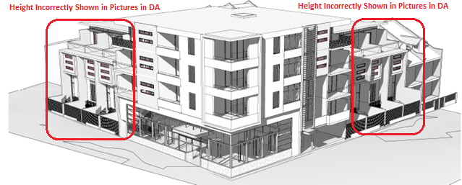
Please lodge your Objections by Email with Council at DASubmissions@cityofsydney.nsw.gov.au & Copy Councillor Linda Scott (who has offered to assist us) LScott@cityofsydney.nsw.gov.au and the Alexandria Residents’ Action Group info@arag.org.au. (*) 2-week extension from 28/11 granted.
When lodging, it is important to reference DA D/2012/1627, include your Email address or phone number for Council to contact you and to CC Councilor Linda Scott and ARAG to track Objections and have the matter heard before Council. It is worth noting that Council does listen to residents; when 70 residents Objected to the Buckland Hotel opening a late-night venue on its top floor, it Rejected the DA. Note: this document & Objection Points are also available from the ARAG website: www.arag.org.au
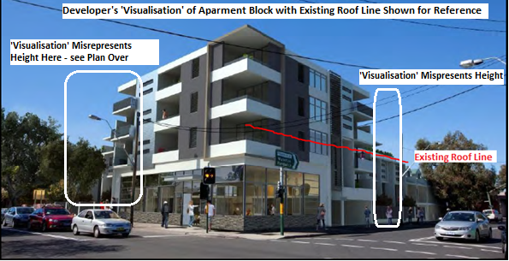
3 Residents’ Groups met over the weekend and the following subset of Objection points were immediately identified (there are too many to list on 1 page, but we are happy to share others by Email):
- The bulk & height are totally out of scale with existing streetscape. The proposed height of 14.7 metres is non-compliant with the current 12m allowable (DA attempts to quote draft 2011 LEP)
- The Floor to Space Ratio (FSR) is above the 1:1 allowable, in fact the DA seeks to have a 50% ‘bonus’ applied to 1.5:1 by paying Council a monetary sum under a ‘Voluntary Planning Agreement’. Details in the DA show that they are further non-compliant as the real FSR is 1.6:1.
- The building of a bulky 5-storey apartment block directly opposite and adjacent to 1 to 2-storey heritage listed areas is completely non-compliant with the current Green Square Development Control Plan (DCP) in particular with the objective to “Encourage design that reinforces unique attributes of Green Square (heritage, contributory buildings, landscape etc.)”
- The large increase in height and bulk will cause very large loss-of-privacy and overshadowing (the ‘shadow diagrams’ show massive impact to the South – particularly in mid-Winter).
- The height of the proposed design and high-density unit layout is non-compliant with NSW’s 2002 ‘SEPP 65’planning policy (introduced to improve design quality of units); inside the block less than the minimum of 70% of units will receive 3 hours sunlight between 9.00-15.00 in mid-Winter.
- The mixture of dwellings is also non-compliant under the current South Sydney Development Control Plan (DCP) –there are nine (9) tiny 50sqm studios which is 41% of total (far higher than the maximum of 30% allowed) and only five (5) 80sqm 2-bedroom units which is 23% of total (far lower than the 40% minimum). Single-brick construction means limited acoustic privacy.
Please note that we are in favour of residential developments that are sympathetic to our area and improve amenity – this DA is not, and also states it’s only Stage 1 (Stage 2 being the smash repair shop).
David / Damien / David / Tony - Buckland Street (bucklandstreet@hotmail.com)

